Six Weeks to a Powerful LIFE REVIEW
By Karen Powers Wan

Congratulations for choosing to honor your life story by creating a document that can be used in many useful and beautiful ways. This guide gives you a six-week process for developing a life review that you will treasure.
Your Life Review can be a personal document written to increase your self-awareness, or as the very beginning organization of a memoir.
You can also create a Life Review for someone you love. None of us know how much time we have in our lives. When we reach midlife and beyond, we want to leave something for the people so they can remember us. This Life Review can be used in a Celebration of Life ceremony, or as a way to organize a loved one’s life story. It can also be a help to those who may be suffering from memory loss or a physical impairment.
However, you want to use this Life Review, taking the time to move through this process will help you create a more genuine, heartfelt and uplifting synopsis of a beautiful life.

Contents
OVERVIEW 3
Six Weeks to a Powerful Life Review 3
Principles of Life Reviewing 4
PART ONE - DISCOVERY 5
Week 1 5
SOUL ACCOMPLISHMENTS 5
OBSTACLES OVERCOME 5
VALUES AND PRIORITIES 5
PART TWO - UNDERSTANDING CORE STORIES 6
Week 2 - Creating Your Opening Page 6
PART THREE - DISCOVERING THEMES 7
WEEK 3 - TRACKING REPEATING CYCLES 7
PART FOUR - THE POWER OF PHOTOS 7
WEEK 4 - BRINGING LIFE TO YOUR REVIEW 8
PART FIVE - THE GOOD YOU CREATED 8
WEEK 5 - CONNECTING TO GOODNESS 8
PART SIX - COMPLETING YOUR LIFE REVIEW 9
WEEK 6 - THE FINISHING TOUCHES 9

OVERVIEW

Six Weeks to a Powerful Life Review
There are several steps to creating your Life Review. And you can skip them all if you simply want to update the template. The template is designed to be very easy to understand and update.
However, I recommend that you take the time to move through the process, if you want to create a more authentic and deeply moving portrait of your life.
These six steps can help you create a more meaningful life review that you will want to share with the people you love.
- Discovering the building blocks of your life
- Understanding Your Core Stories
- Discovering Your Life’s Themes
- Choosing Meaningful Photos
- Understanding Your Innate Goodness
- Pulling it All Together

Principles of Life Reviewing
A Life Review is meant to uplift you. This is not a time to focus on guilt, shame, or regret. We’re looking at how life went well for you, and what you learned from both the difficult and the easy aspects of your life.
- Non-judgmental
- Inspiring
- Unique to You
- Caring and Sharing

A Life Review helps you to get to know yourself in a way that you may have never done before. The process is simple, but often we don’t take the time to look at how we have made decisions and what’s worked best for our heart and soul.

PART ONE - DISCOVERY

Week 1
This week see if you can check off these parts of the Discovery Process.
- Soul Accomplishments
- Obstacles Overcome
- Values and Priorities

SOUL ACCOMPLISHMENTS
Lorem ipsum dolor sit amet, consectetuer adipiscing elit, sed diam nonummy nibh euismod tincidunt ut laoreet dolore magna aliquam erat.

OBSTACLES OVERCOME
Lorem ipsum dolor sit amet, consectetuer adipiscing elit, sed diam nonummy nibh euismod tincidunt ut laoreet dolore magna aliquam erat.

VALUES AND PRIORITIES
Lorem ipsum dolor sit amet, consectetuer adipiscing elit, sed diam nonummy nibh euismod tincidunt ut laoreet dolore magna aliquam erat.
If you like, you can start editing the Life Review template. I recommend starting with the opening page. You will finish that page next week.

PART TWO - UNDERSTANDING YOUR CORE STORIES

Week 2 - Creating Your Opening Page
If you went through the week one activities, you have already compiled some important information about yourself. This week your goal is to create an opening page with one or more of the following elements.
- Origin Story
- Gifts and Talents
- Turning Point
- Relationships

You may want to start saving different versions of your Life Review. I recommend keeping a few different versions, because you may change your mind as you go through the process. You don’t want to lose work that you created. So, this week create version 1 of your Life Review.

PART THREE - DISCOVERING THEMES

WEEK 3 - TRACKING REPEATING CYCLES
This week’s activity builds upon what you have been noticing in your first few weeks. You may have already been noticing the following:
- Recurring Patterns
- Best Qualities
- Skills You Keep Needing to Use
Our goal this week is to begin shaping the topics you want to include in your life review, based on themes in your life as well as the priorities and values you already noticed.
We want your Life Review to emphasize your best qualities, and the skills you developed and cherished over the course of your life.
You can either answer your questionnaire at this point, or you can edit your Life Review template.
Again, you might want to save version 2 of your Life Review this week to track your progress through the Life Review.

PART FOUR - THE POWER OF PHOTOS

WEEK 4 - BRINGING LIFE TO YOUR REVIEW
You can create a Life Review without photos, but it won’t be as powerful.
This week’s assignment is to choose photos from your life that have great meaning to you. They might relate to any of the discovery and stories you uncovered in the first three weeks of your Life Review process.
If you’re anything like me, you might have already added some photos to your Life Review template.
This week, take some time to start finalizing the pictures you want to include in your Life Review.
To change a picture in the template, simply click on it to select the picture. Then click on it again to replace the picture.

PART FIVE - THE GOOD YOU CREATED

WEEK 5 - CONNECTING TO GOODNESS
We’re almost finished with your Life Review.
This is the week to connect with the ways that you made a positive difference in the world or someone else’s life.
- Love
- Peace
- Compassion
- Support
These are lofty categories related to the idea of goodness. You may want to look at different categories like humor, adventure. Choose 2-4 categories to explore this week. The goal of this week is to make sure that you have captured all the best aspects of your life or the person you are reviewing.

Remember that you don’t need to share the notes you’re taking. This process is for you to realize how much good you have created in your life, and then choose the most important moments and realizations in your Life Review.

PART SIX - COMPLETING YOUR LIFE REVIEW

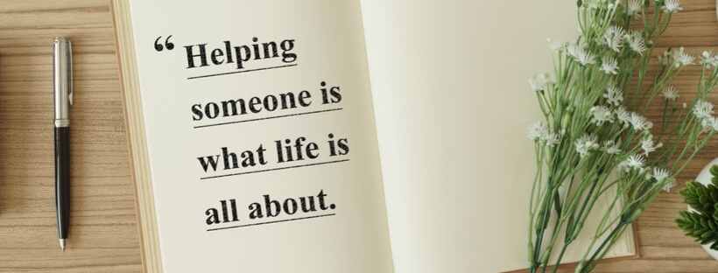

WEEK 6 - THE FINISHING TOUCHES
This is the week when you pull together all the advice you might want to share with yourself or the people you love.
You don’t have to create a bonus page for sharing your advice. Some people don’t like to give advice. However, people you love might want to know what you learned in the process of your life.
- Optional Bonus Page - Sharing Your Advice and Wisdom
- Your About Page
- Combining Photos with Snippets of Stories
Now that you have completed all the questions and exercises, this is the best time to create your About Page. If you’ve already done it, that’s good too.
In the last week, you’re putting together everything you’ve collected, discovered, and remembered. You should be able to complete your Life Review, of course, depending on what else is happening in your life.
Enjoy this week, and know that you have created a book that captures the miracle of your life, and may be very precious to someone who loves you.

